Casey Burkhardt
HPAir Screenshots
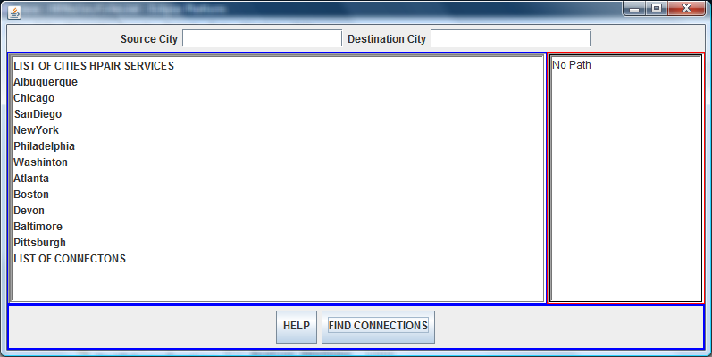
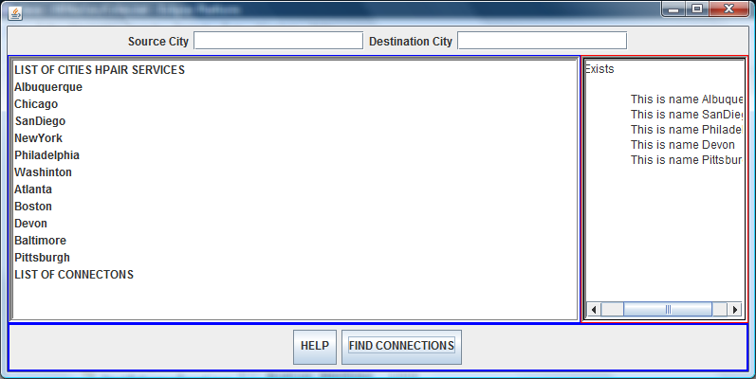

import java.util.Iterator;

public class GraphListDirected extends Graphlist
{

/**
* Construct a directed, adjacency-list based graph.
*
* @post constructs an directed graph
*/
public GraphListDirected()
{
super(true);
}

/**
* Add an edge between two vertices within the graph. Edge is directed.
* Duplicate edges are silently replaced.
* Labels on edges may be null.
*
* @pre vLabel1 and vLabel2 are labels of existing vertices, v1 & v2
* @post an edge is inserted between v1 and v2;
* if edge is new, it is labeled with label (can be null)
*
* @param vLabel1 Source vertex.
* @param vLabel2 Destination vertex.
* @param label Label associated with the edge.
*/
public void addEdge(Object vLabel1, Object vLabel2, Double label)
{
// get vertices with the label parameters
VertexS v1 = (VertexS) dict.get(vLabel1);
VertexS v2 = (VertexS) dict.get(vLabel2);
// create and edge with the vertices
Edge e = new Edge(v1.label(), v2.label(), label, true);
// add the edge to v1, the source vertex's linked list
v1.addEdge(e);
}

/**
* Remove a vertex from the graph. Associated edges are also
* removed. Non-vertices are silently ignored.
*
* @pre label is non-null vertex label
* @post vertex with "equals" label is removed, if found
*
* @param label The label of the vertex within the graph.
* @return The label associated with the vertex.
*/
public Object remove(Object label)
{
VertexS v = (VertexS)dict.get(label);

Iterator vi = dict.values().iterator();
while (vi.hasNext())
{
Object v2 = vi.next();
if (label.equals(v2)) removeEdge(v2,label);
}
dict.remove(label);
return v.label();
}

/**
* Remove possible edge between vertices labeled vLabel1 and vLabel2.
* vLabel1 is the source.
*
* @pre vLabel1 and vLabel2 are labels of existing vertices
* @post edge is removed, its label is returned
*
* @param vLabel1 Source vertex.
* @param vLabel2 Destination vertex.
* @return The label associated with the edge removed.
*/
public Object removeEdge(Object vLabel1, Object vLabel2)
{
VertexS v1 = (VertexS) dict.get(vLabel1);
VertexS v2 = (VertexS) dict.get(vLabel2);
Edge e = new Edge(v1.label(), v2.label(), null, true);
e = v1.removeEdge2(e);
if (e == null)
return null;
else
return e.label();
}

/**
* Determine the number of edges in graph.
*
* @post returns the number of edges in graph
*
* @return Number of edges in graph.
*/
public int edgeCount()
{
int count = 0;
Iterator i = dict.values().iterator();
while (i.hasNext())
count += ((VertexS) i.next()).degree();
return count;
}

/**
* Construct a string representation of graph.
*
* @post returns string representation of graph
*
* @return String representing graph.
*/
public String toString()
{

return "<GraphListDirected: "+dict.toString()+">";
}

public Iterator neighbors(Object label)
{
// return towns adjacent to vertex labeled label
//Assert.condition(dict.containsKey(label), "Vertex exists");
return ((VertexS) dict.get(label)).adjacentVertices();
}
/*
* //---------------------------------------------------
//Determines whether a sequence of flights between
//two cities exists. Nonrecursive stack version.
// keeps track of cities visited in the path in Queue
//Precondition: originCity and destinationCity are
//the origin and destination cities, respectively.
//Postcondition: Returns true if a sequence of
//flights exists from originCity to destination City,
//otherwise returns false. Cities visited during the
//search are marked as visited. A queue of visited cities in the path is returned
//---------------------------------------------------*/

//Method to determine if there is a sequence of flights
public CircularArrayQueue isPath(Label originCity, Label destinationCity)
{

StackReferenceBased stack = new StackReferenceBased();
CircularArrayQueue que = new CircularArrayQueue();
Label topCity, nextCity;
reset(); // clear marks on all cities
VertexS vs;
Iterator iter;

// push origin city onto stack, mark it visited
stack.push(originCity);

// peek at item on the top of the stack and store in variable topcity, you will have to cast it to a label
topCity =(Label)stack.peek();

// call neighbors method which returns an iterator of the adjacent cities to topcity e.g
iter = neighbors(topCity);
// loop while stack is not empty and the topcity is not equal destination ciy
while (!stack.isEmpty() && (topCity.compareTo(destinationCity) != 0))
{
// call method to get NextCity defined below
nextCity = (Label)getNextCity(iter);
// if next city is null
if(nextCity == null)
{
// peek at the stack again
topCity =(Label)stack.peek();

// call the neighbors method again with topcity
iter = neighbors(topCity);

// pop the stack
stack.pop();
}
else
{
// push nextcity on the stack and mark it visite
stack.push(nextCity);
// insert it into the queue
que.insert(nextCity);
// peek at the city on top of the stack again
stack.peek();
} // end else
} // end while

// If Stack is empty, no path exists, return null else return the queue
if(stack.isEmpty())
return null;
else
return que;

} // end isPath

// gets the next city on the path, determines it is either null or visited, otherwise returns the city
public Label getNextCity( Iterator iter)
{
Label nextCity;
if(!iter.hasNext())
return null;
else
{
nextCity = (Label) iter.next();
VertexS vs = (VertexS)dict.get(nextCity);

if (vs.isVisited())
return null;

return nextCity;
}
}
}// end class

//********************************************************************

//
// Demonstrates a simulation of an airline scheduling system using a
// weighted graph data structure and a HashTable
//********************************************************************

import java.io.*;

import java.util.*;
import java.awt.*;
import java.awt.event.*;
import javax.swing.*;
import java.util.Iterator;

public class HPAirGUI extends JFrame
{
//-----------------------------------------------------------------
// Creates a new network and populates it with data from a file
// which contains the distance of flights to various cities. The user
// enters two cities and the program returns whether or not there is a flight
// between the two cities.
//-----------------------------------------------------------------
private String fileIn = "Cities.txt";
private JTextArea textbox;
private DefaultListModel listModel;

private JList jList;

private JButton helpButton, FindIndirectButton;
private JTextField firstCity, secondCity;
private JLabel sourceCity; // Setup input labels
private JLabel destinationCity;
private ActionHandler action;
private GraphListDirected cities;

public HPAirGUI()
{
// creates the graph to used to store cities and the their connections
cities = new GraphListDirected();
// create the listener for the buttons
action = new ActionHandler();

// create a JTextArea to itineraries
textbox = new JTextArea(5, 15);
textbox.setText("THIS IS YOUR INTINERARY");
JScrollPane scrollingArea = new JScrollPane(textbox);

scrollingArea.setBorder(BorderFactory.createEmptyBorder(5,5,5,5));
scrollingArea.setBorder(
BorderFactory.createCompoundBorder(
BorderFactory.createCompoundBorder(
BorderFactory.createLineBorder(Color.red),
BorderFactory.createLoweredBevelBorder()),
BorderFactory.createCompoundBorder(
BorderFactory.createLineBorder(Color.black),
BorderFactory.createLoweredBevelBorder())));

// displays the list of cities HPAir Services
listModel = new DefaultListModel(); // Setup Listbox
jList = new JList(listModel);
jList.setSelectionMode(ListSelectionModel.SINGLE_SELECTION);
jList.setSelectedIndex(-1);
// jList.addListSelectionListener(this);
JScrollPane listScrollPane = new JScrollPane(jList);

// set up a compound border for the Jlist object
listScrollPane.setBorder(
BorderFactory.createCompoundBorder(
BorderFactory.createCompoundBorder(
BorderFactory.createLineBorder(Color.blue),
BorderFactory.createLoweredBevelBorder()),
BorderFactory.createCompoundBorder(
BorderFactory.createLineBorder(Color.gray),
BorderFactory.createLoweredBevelBorder())));

// Create all the buttons
FindIndirectButton = new JButton("FIND CONNECTIONS"); // Setup Buttons
FindIndirectButton.setToolTipText("Finds Connections Between Two Cities");
FindIndirectButton.setMargin(new Insets(5,5,10,5));

FindIndirectButton.addActionListener(action);

helpButton = new JButton("HELP"); // Setup Buttons
helpButton.setToolTipText("Instructions ");
helpButton.setMargin(new Insets(5,5,10,5));

helpButton.addActionListener(action);

JPanel buttonPane = new JPanel();
buttonPane.setBorder(BorderFactory.createLineBorder(Color.blue,2));
buttonPane.add(helpButton);

buttonPane.add(FindIndirectButton); // Attach buttons
//sets up the textfields for entering source and destination cities
firstCity = new JTextField(16); // Setup input fields
secondCity = new JTextField(16);
sourceCity = new JLabel("Source City"); // Setup input labels
destinationCity = new JLabel("Destination City");

JPanel fieldPanel = new JPanel();
fieldPanel.add(sourceCity);
fieldPanel.add(firstCity);
fieldPanel.add(destinationCity);
fieldPanel.add(secondCity);
// read in cities and their connections
BuildGraph();

Container c = getContentPane();
c.add(listScrollPane, BorderLayout.CENTER);
c.add(buttonPane, BorderLayout.SOUTH);
c.add(scrollingArea, BorderLayout.EAST);
c.add(fieldPanel, BorderLayout.NORTH);

}

/********************************************************************
* BuildGraph Method : I put the two input files, cities and then cities and
* and their connections into one file, so I did not need two methods to read them
* in. I simply read in the cities, create a label for each one, and call a method in
* graphlist which adds them to the hashtable. See the add method in GraphList
* which uses the label to create a vertex and then adds the label and vertex to the
* Hashtable
* After reading in the cities I read in the cities and the connections
*between cities from the input file and add edges to the graph from city1 to city2.
* It also outputs the cities
* **********************************************************/
public void BuildGraph()
{
try {
Scanner scan = new Scanner(new File("Cities.txt"));
Scanner linescan;

String line, city1, city2;
double cost, distance;
int numCities;
Label label;
listModel.addElement("LIST OF CITIES HPAIR SERVICES");

//loop though lines to get data
// read in cities, create labels with them and add them to the hashtable
line = scan.nextLine();//reads in a line from the file
while(line.length() != 0 )
{
label = new Label(line);
cities.add(label);
listModel.addElement(line);

line = scan.nextLine();//reads in a line from the file
}

// Read in the connections between cities from the input
// file and add edges to the graph from city1 to city2.
listModel.addElement("LIST OF CONNECTONS");
while(scan.hasNext())
{
line = scan.nextLine();
// create a scanner object to loop through text in each line
linescan = new Scanner(line);
// to break up the line of input into usable fields -

city1 = linescan.next();
city2 = linescan.next();
distance = linescan.nextDouble();
Label label1 = new Label(city1);
Label label2 = new Label(city2);
cities.addEdge(label1, label2, (Double)distance);
}

}
catch(FileNotFoundException e)
{
System.out.println("File Not Found: ") ; // !!FILE_NOT_FOUND
}
catch(IOException e)
{
System.out.println("IOException " + e.getMessage() ); // !!READ_ONLY!!
}

}// close method

/****************************************************************************
* class A
****************************************************************************/
class ActionHandler implements ActionListener
{
Label l1, l2;
CircularArrayQueue que;
boolean ispath = false;

public void actionPerformed(ActionEvent e) // 'ADD' button was pressed
{

if(e.getActionCommand().equals("HELP"))
JOptionPane.showMessageDialog (null, "Enter two cities to determine if there is a flight ",
"INSTRUCTIONS", JOptionPane.PLAIN_MESSAGE );

if (e.getActionCommand().equals("FIND CONNECTIONS"))
{ // gets connections
textbox.setText("");

// get origin and destination city
String c1 = firstCity.getText();
String c2 = secondCity.getText();

// create a label for each city
Label l1 = new Label(c1);
Label l2 = new Label(c2);

// call the method isPath with the labels
// isPath returns aCcircularArrayQueue
// which is instantiated above as "que"
que = cities.isPath(l1, l2);

//if the que is null, output the appropriate message
if(que == null)
textbox.setText("No Path");
else
// output the appropriate message that there is a connection]
// and output the que ( you can use que.toString())
//System.out.println(" In find connection after getting que" + que.toString());
textbox.setText("A Path Exists\n" + que.toString());

firstCity.setText("");
secondCity.setText("");
}

} // close actionperformed
} //close ActionHandler

}//class CheapestFlight

/* public static void readFiles (String[] args)
{
String file = "flights.txt";
/* try
{
BufferedReader inFile = new BufferedReader(new FileReader(file));
BufferedReader keyboard = new BufferedReader(new InputStreamReader(System.in));
// Network<String> cities = new Network<String>();
StringTokenizer tokenizer;
String line, city1, city2;
double cost;
int numCities;

// Read in the list of cities from the input file and add
// add them to the network. List of cities will be
// terminated by a blank line.
line = inFile.readLine();
while (line.length() != 0)
{
cities.addVertex(line);
line = inFile.readLine();
}

// Read in the connections between cities from the input
// file and add them to the network.
line = inFile.readLine();
while (line != null)
{
tokenizer = new StringTokenizer(line, "\t\n");
city1 = tokenizer.nextToken();
city2 = tokenizer.nextToken();
cost = Double.parseDouble(tokenizer.nextToken());
cities.addEdge(city1, city2, cost);
line = inFile.readLine();
}

// Display the list of cities
numCities = cities.size();
Iterator<String> cityiterator = cities.iteratorBFS(0);

System.out.println("Cities");
System.out.println("------");
while (cityiterator.hasNext())
{
System.out.println(cityiterator.next());
}
// Prompt the user to enter two cities
System.out.print("\nCity 1: ");
city1 = keyboard.readLine();
System.out.print("\nCity 2: ");
city2 = keyboard.readLine();

// Display the shortest path between the two cities and
// how much it would cost
cost = cities.shortestPathWeight(city1, city2);
if (cost < Double.POSITIVE_INFINITY)
{
System.out.print("\nThe cheapest path from " + city1 + " to " + city2 + " is ");
NumberFormat money = NumberFormat.getCurrencyInstance();
System.out.println(money.format(cities.shortestPathWeight(city1, city2)));
System.out.print("You would have to travel from ");
Iterator<String> it = cities.iteratorShortestPath(city1, city2);
while (it.hasNext())
{
System.out.println(it.next());
if (it.hasNext())
System.out.print(" to ");
}
}
else
System.out.println("\nThere is no path from " + city1 + " to " + city2);
}

catch (FileNotFoundException e) {System.out.println("file " + file + " not found");}
catch (IOException e) {System.out.println("IO exception");}

}//method main
*/

